FOOD AND FITNESS
The Ultimate way to lose weight quick

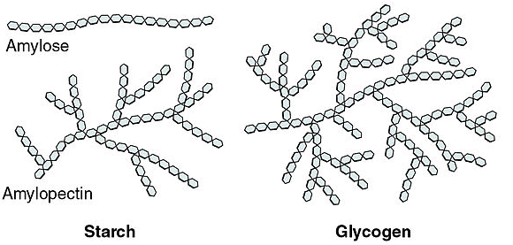


The Ketogenic Diet that has been a popular diet that has been around for quite some time that has shown tremendous results in the very short amount of time. The Keto diet consists if a low carb intake diet that allows the body to go into the state of ketosis which helps your body increase the rate that it breaks down fat for energy. The Ketogenic diet actually shows in research that it is far superior to the recommended low- fat diet. Lowering risk factors to disease and showing that people have lost 3 times the amount of weight they would if they were doing a recommended diet.
Our body and the way it breaks down sugar is a complex and long process. These sugars consist of Monosaccharides (1 sugar unit), Disaccharides (2 sugar units), Oligosaccharides (3 sugar units), and Polysaccharides (10 or more sugar units). Obviously the longer the unit the longer it takes to break down and burn off, and Carbohydrates are made up of Polysaccharides which is why it takes so long to burn. Thus, if you consume less of Carbohydrates you can burn a lot quicker leading you to lose more weight.

The Key to losing weight fast is to replace all of the fat with muscle. The diet is a big aspect in doing so but the other crucial piece is working out. Using stations is the best way to maximize your workout, this way it gives you very little rest time and keeps your heart rate pumping. Pretty much like a super-set; If you are targeting one area such as chest create 3 stations and do 10 reps on each station with little as 30 sec-1min break in between. This way there will be less recovery time in your muscles making it adapt to become stronger and build more muscle endurance.

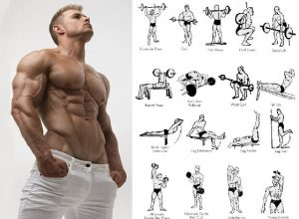
Controlling your water weight would be the next step in burning more fat and losing weight quick. Which can be done by the low carb diet. As well as going into the sauna for about 30 mins and from there directly running on the treadmill for a mile or more or at high intensity. This way whatever you are working out next you will be targeting the fat and burning it a lot quicker.
Resources
https://www.healthline.com/nutrition/ketogenic-diet-101#weight-loss
https://www.healthline.com/nutrition/13-ways-to-lose-water-weight
https://www.mayoclinic.org/healthy-lifestyle/weight-loss/in-depth/low-carb-diet/art-20045831
https://www.muscleandfitness.com/muscle-fitness-hers/hers-workouts/12-exercises-sculpt-stronger-leaner-legs
https://www.active.com/fitness/articles/why-you-should-be-doing-superset-workouts
https://blog.lafitness.com/2014/10/17/the-next-level-30-minute-body-defining-workout/

